

Qpid High Availability Setup and Testing

Railroad | Project |  |  |  |  | Delivery Date: |  |  | Approval Date:
Prepared By: |  | Girish Chandrashekar
 |  |  |  |  | Signature |  |  |  |  | yyyy-mm-dd
Verified By: |  | W. Lowe
 |  |  |  |  | Signature |  |  |  |  | yyyy-mm-dd
Approved By: |  | B. Mageswaran
 |  |  |  |  | Signature |  |  |  |  | yyyy-mm-dd
This document contains proprietary and confidential data of Wabtec Corporation. No disclosure, reproduction, or use of any part thereof may be made without written permission of the Wabtec Corporation.  © Copyright 2017, Wabtec Holding Corp. |  |  | Identity Number:
 |  |  | W1-0000001-0003
 |  |  | Effective Date (yyyy-mm-dd): |  |  |  | Revision: |  |  |  | Language:
 |  |  | 2017-08-02 |  |  |  | 1.0 |  |  |  | English

Revision History
Revision | Date  (yyyy-mm-dd) | Description of Changes
1.0 | 2017-08-02 | Initial release.

Initial Settings:
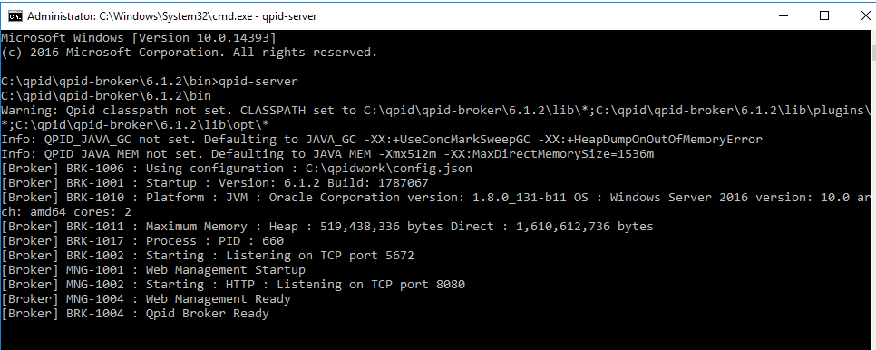
- Start the Node1

- Delete the default Virtual host

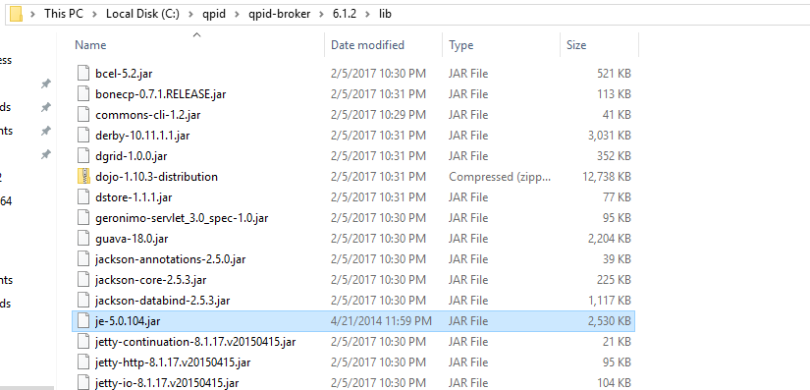
- To get the BDB_HA download and copy je-5.0.104.jar into the lib folder of Qpid.

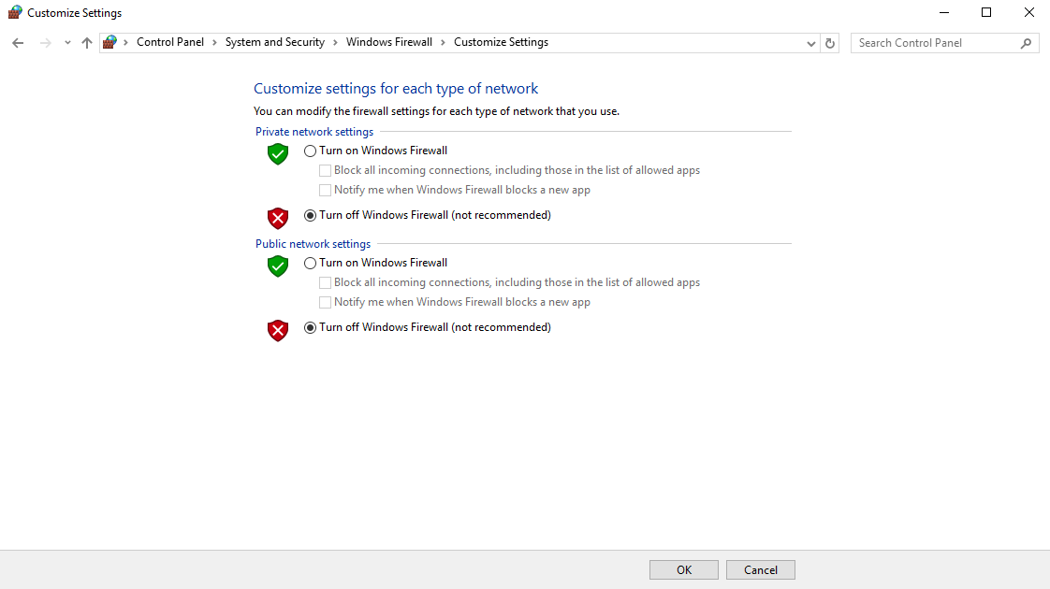
- Make sure you have disabled the firewall

- Select Type as BDB_HA
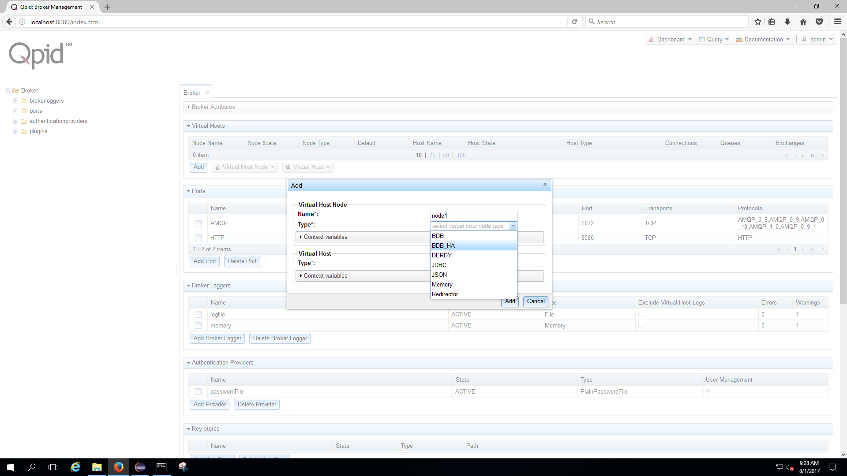

Node1: (10.1.2.52)
- Create new group and mention the address of the host
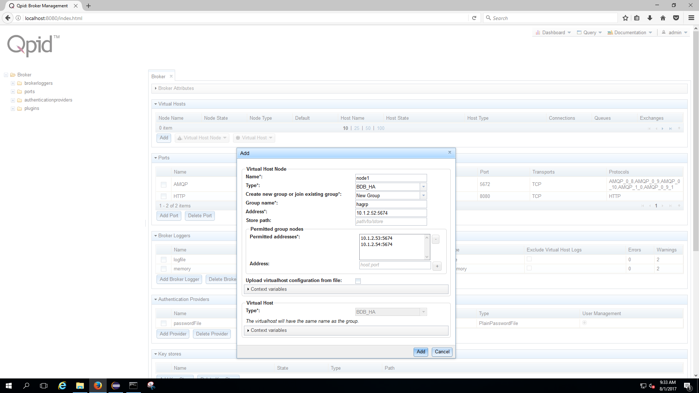
- In the permitted address, mention the address and port of the other two nodes. In our example all the nodes are communicating through 5674 port.

- Here below is the picture depicts how node1 looks like
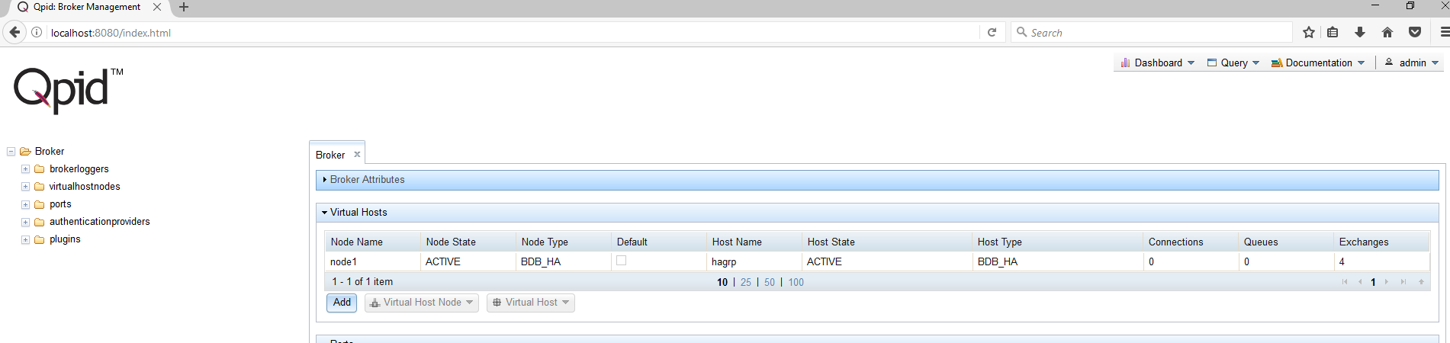

Node2: (10.1.2.53)
- Create node2 with the details shown below, use the group name and node1(MASTER) details

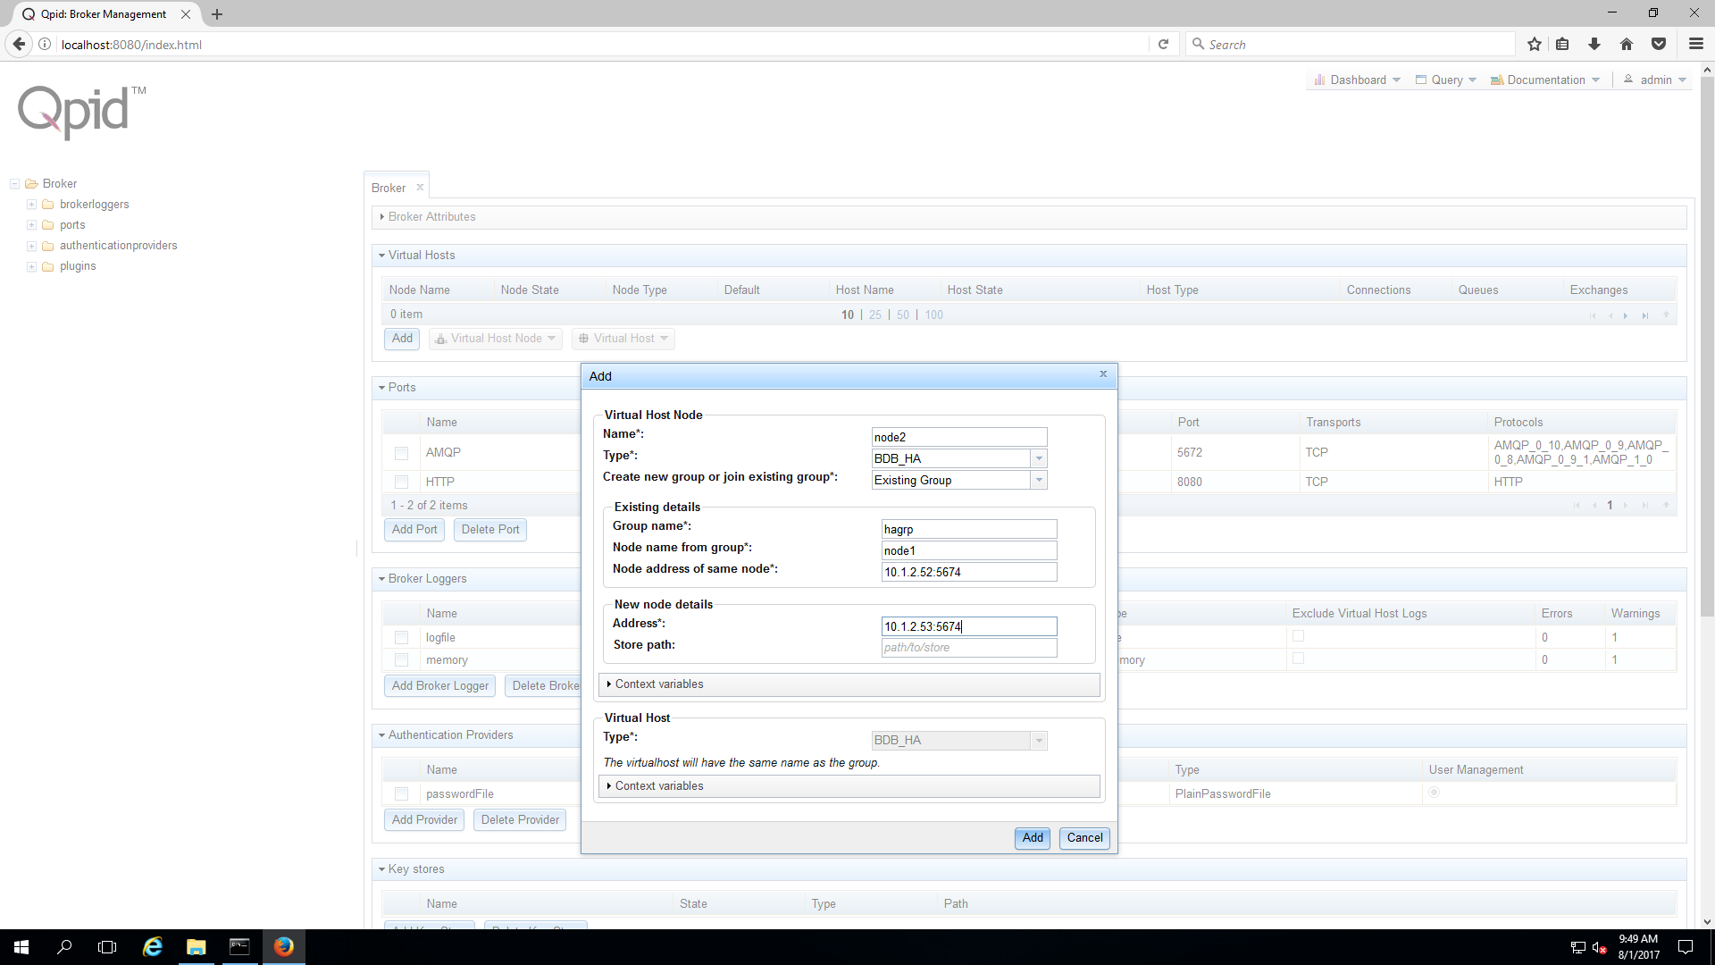

- You can see the node1 and node2 as Master and REPLICA in the Virtual Host Node Attributes

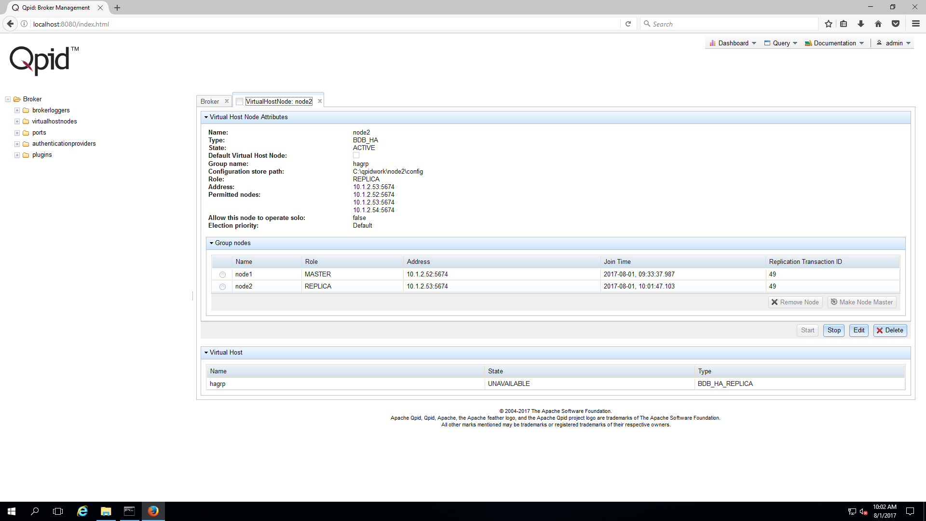

Node3: (10.1.2.54)
- Create node3 by using the group name and node1(MASTER) details

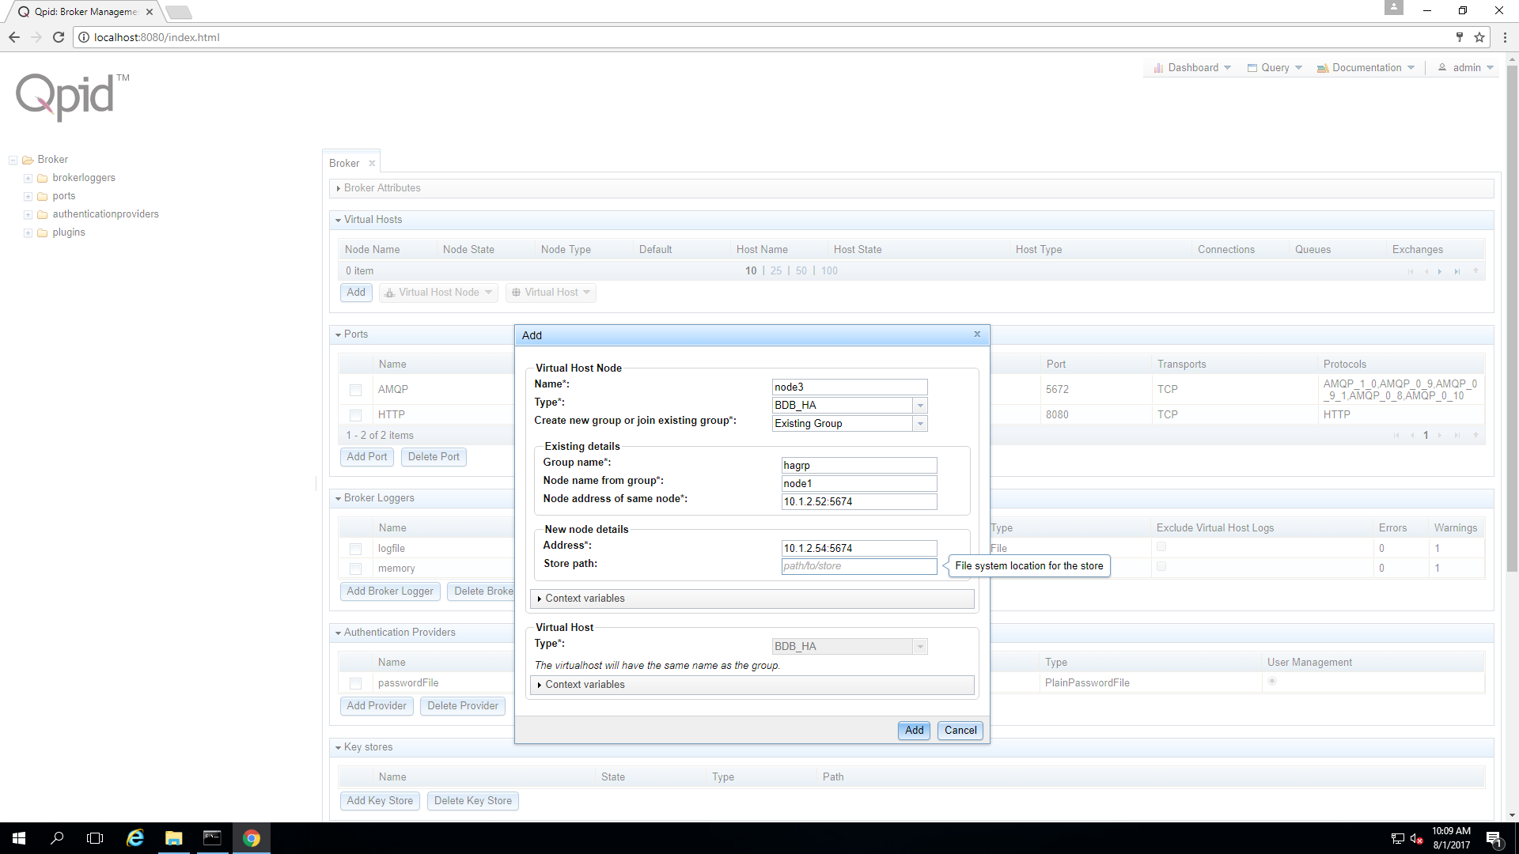

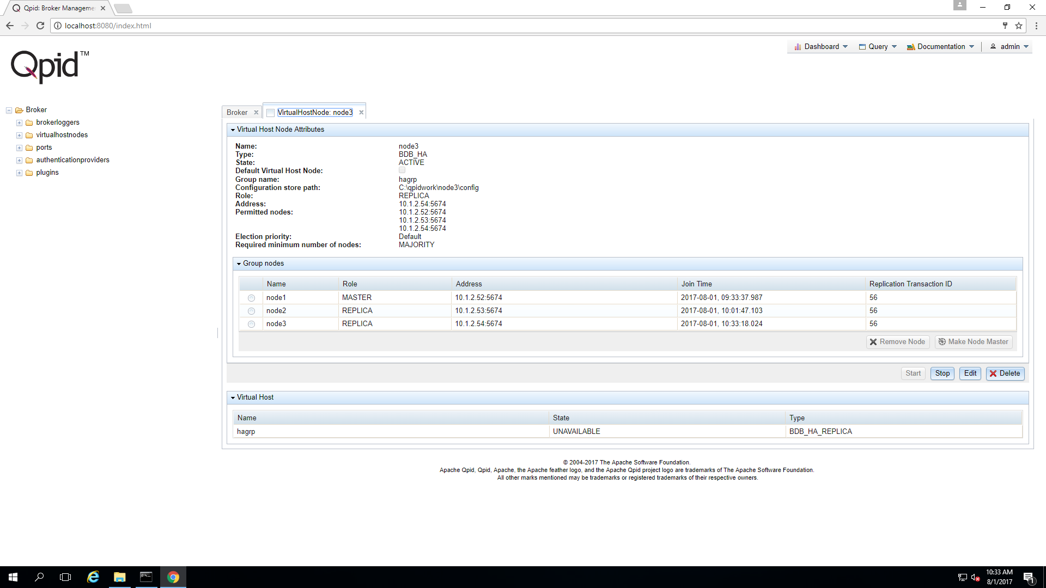
- You can observe the all the three node details in the virtual node attributes section of any node

Testing HA:
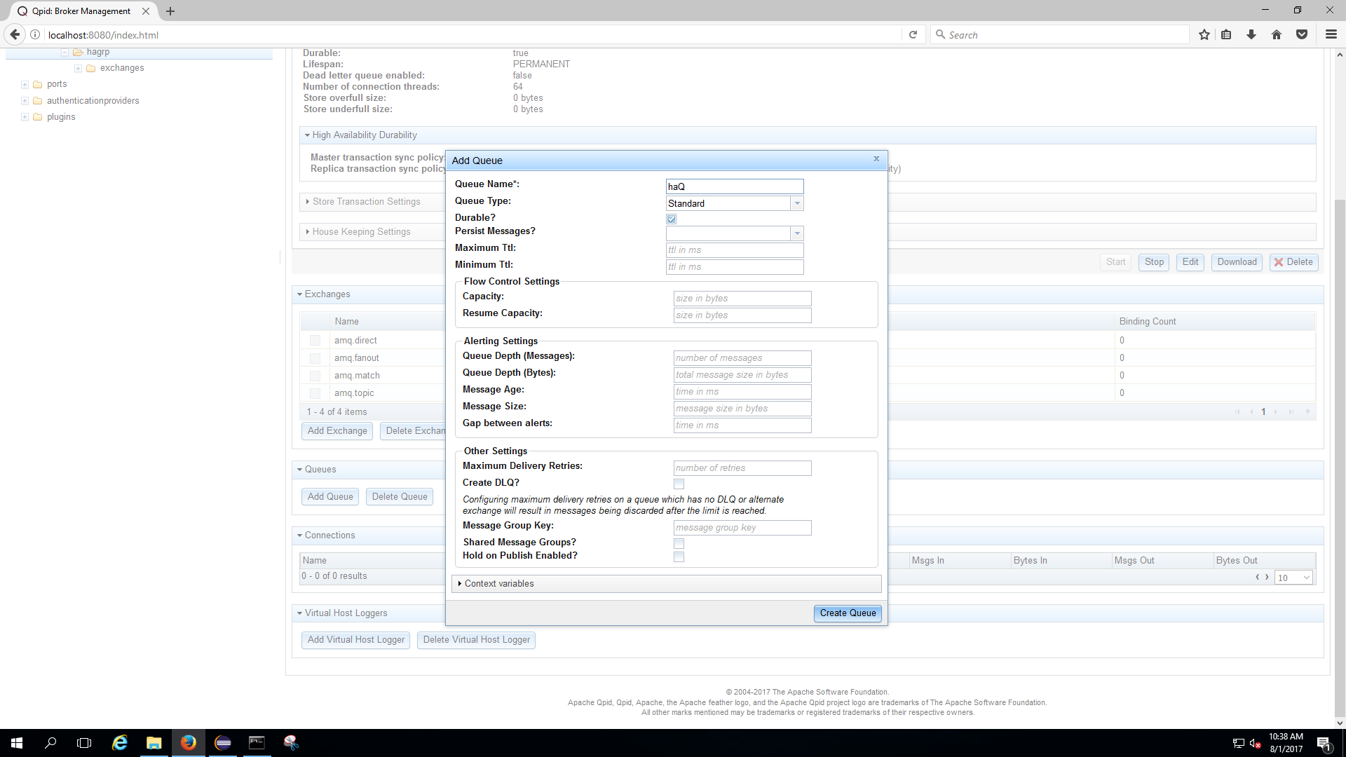
- Create a Queue in the node1 (MASTER) node.

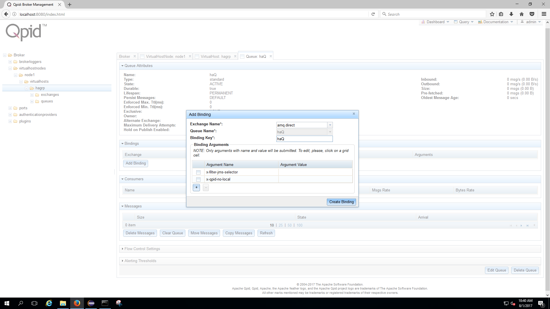
- Add bindings to the Queue

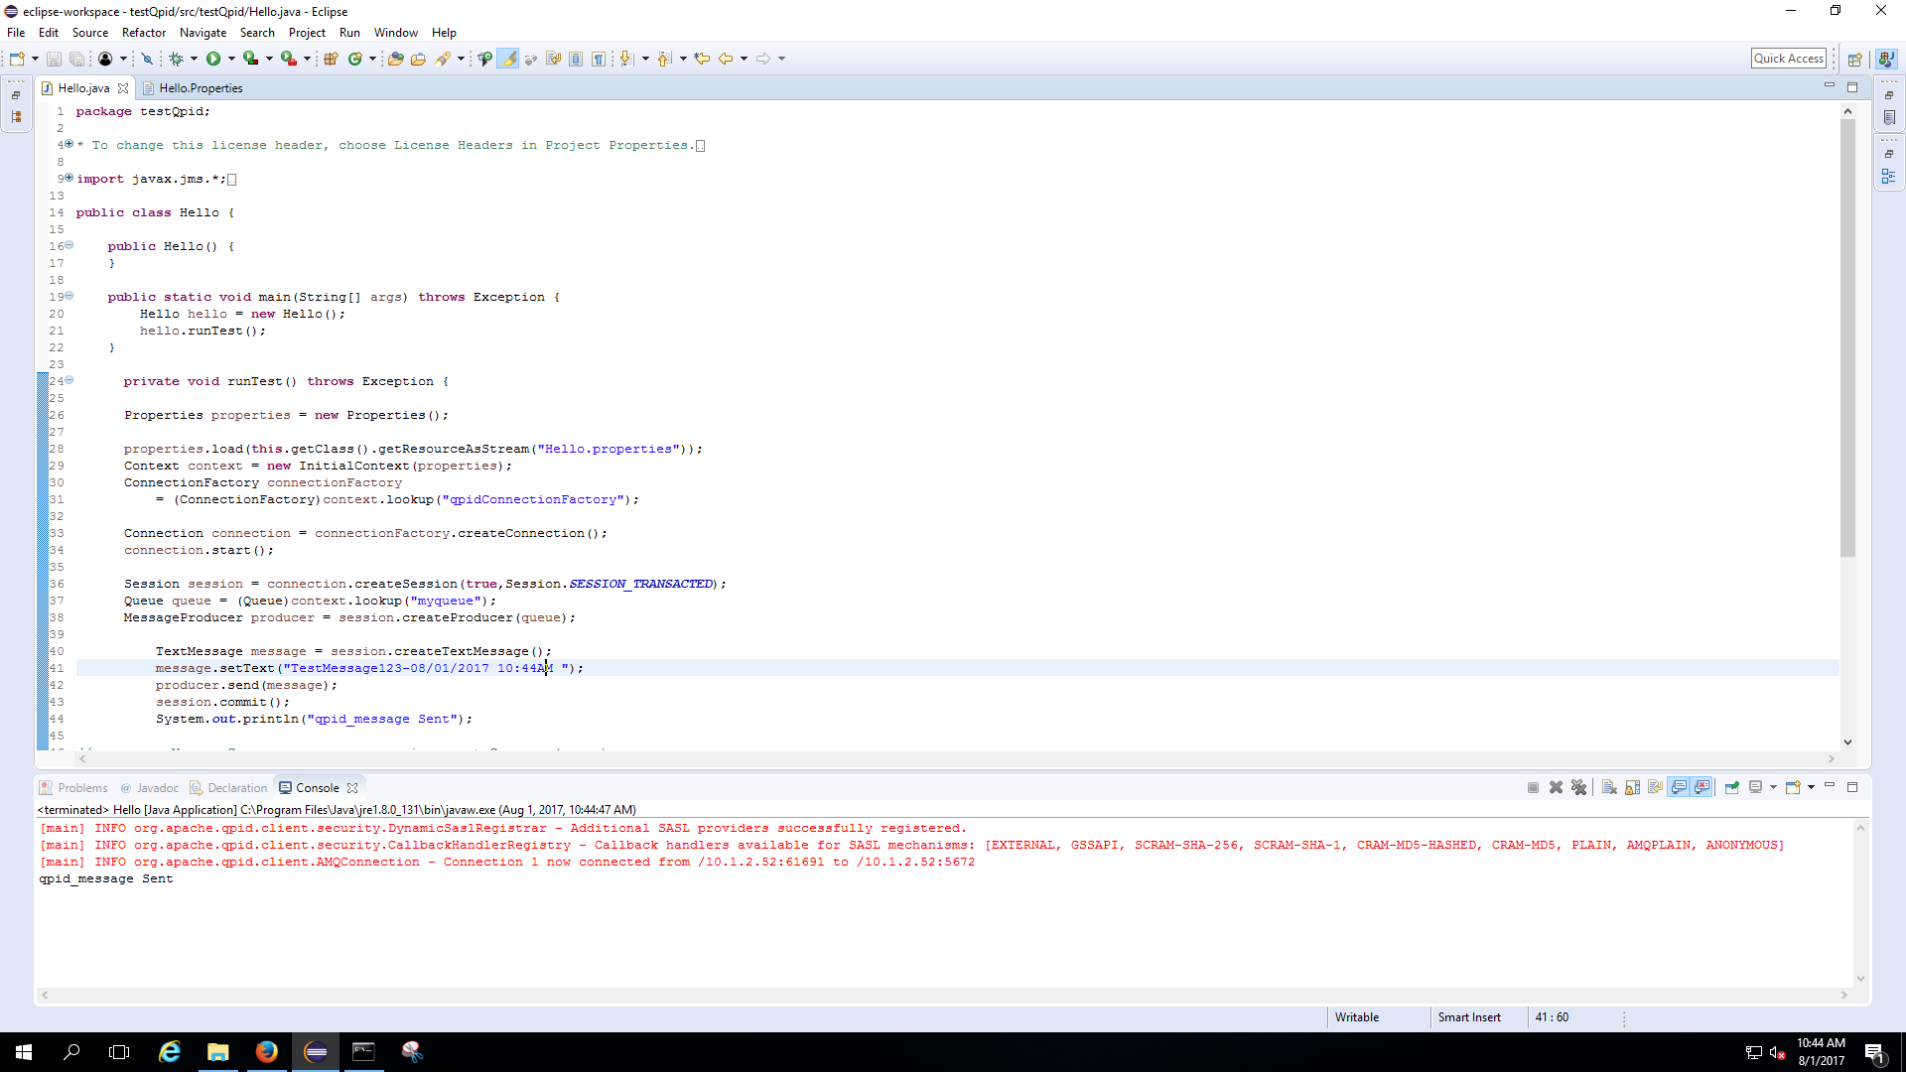
- Send message to the node1

- Sample properties file

- You can see the message reached to eh haQ of node1
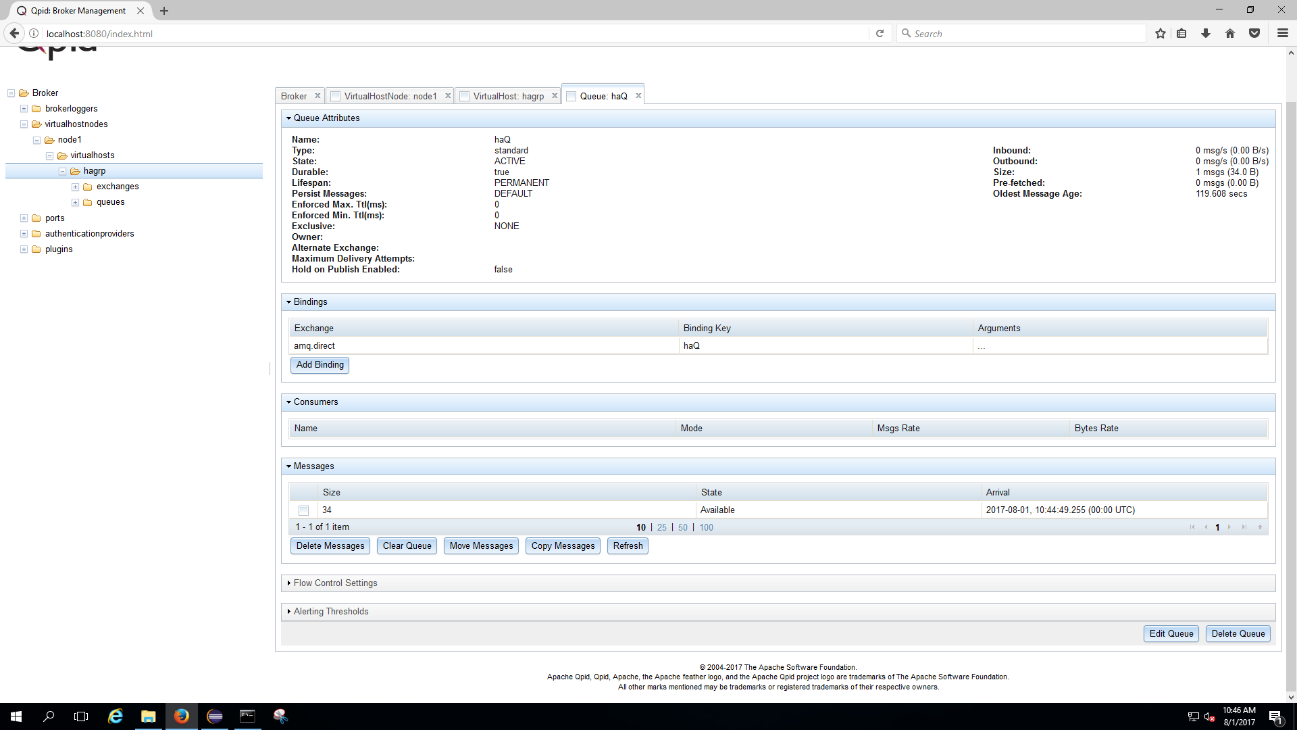

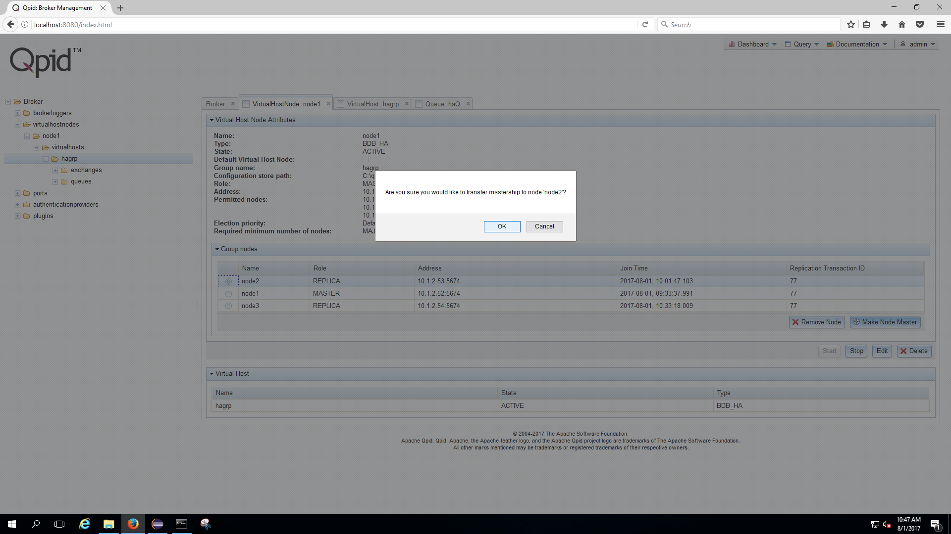
- Now make node2 as MASTER and see the message in the node2 haQ automatically

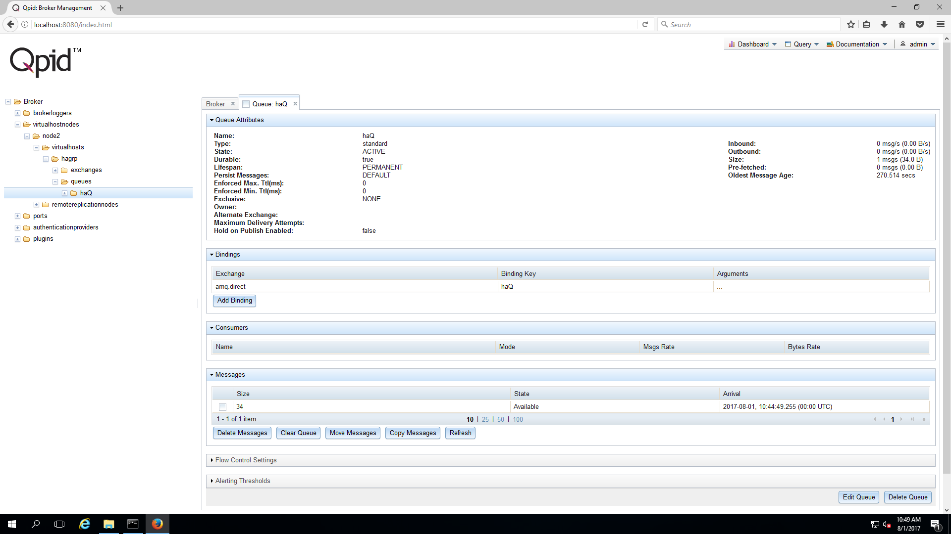
- Make sure you refresh the Web management portal to observe the changes in node2

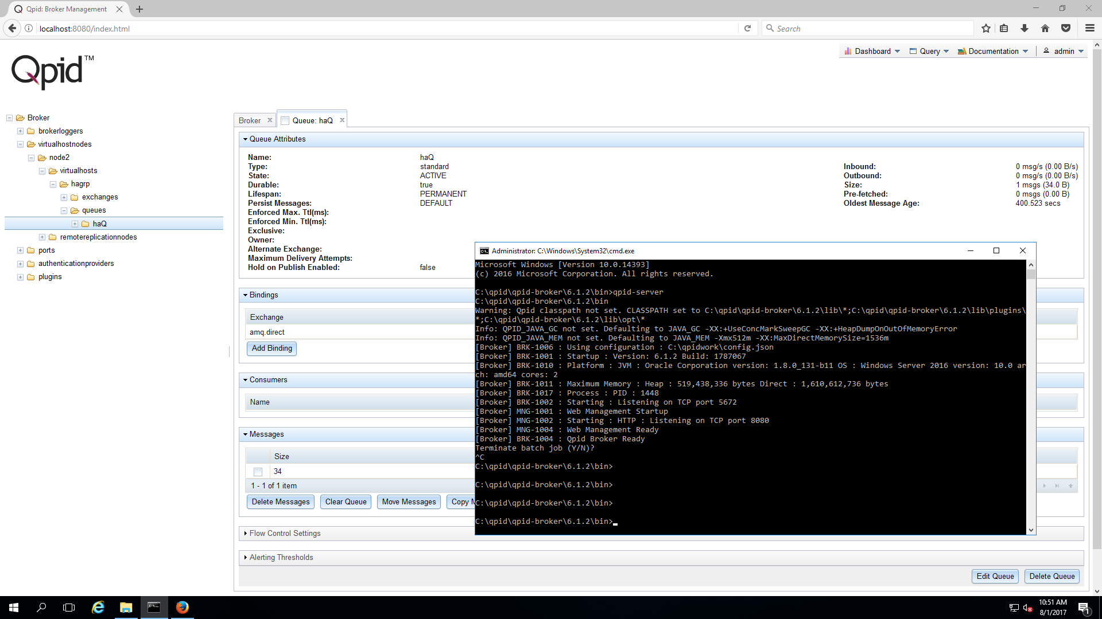
- Now disconnect the Node2(MASTER) and observe how HA of Qpid configuration makes automatically any other node(REPLICA) as MASTER and move the message to that new master Node

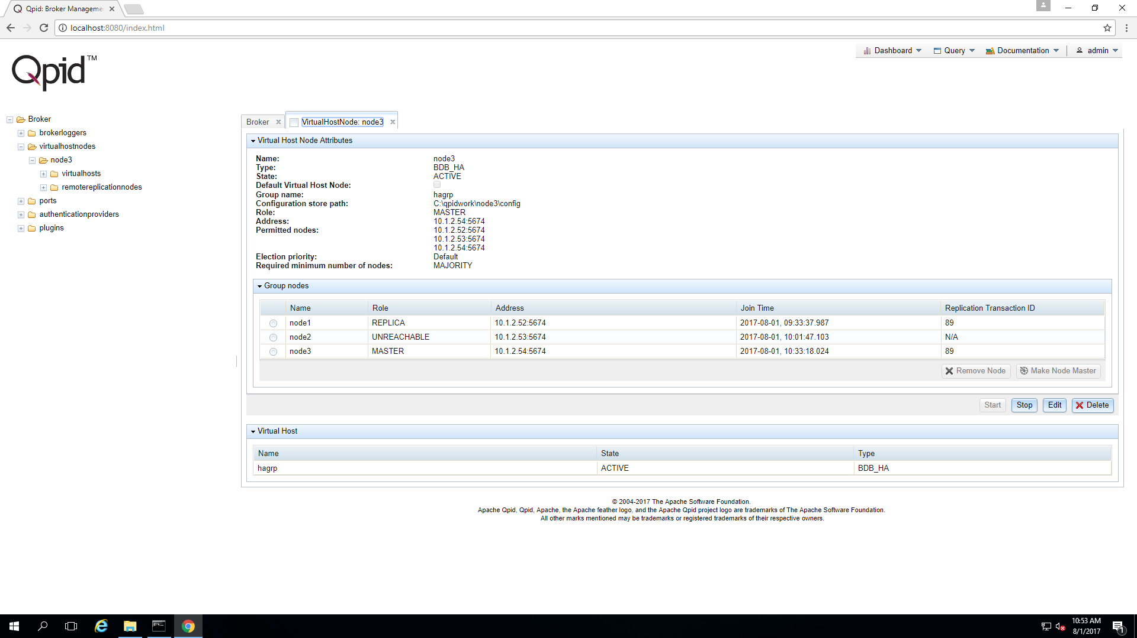
- Now node3 becomes MASTER and find the haQ and message in that Queue

- Check the message in the Queue haQ
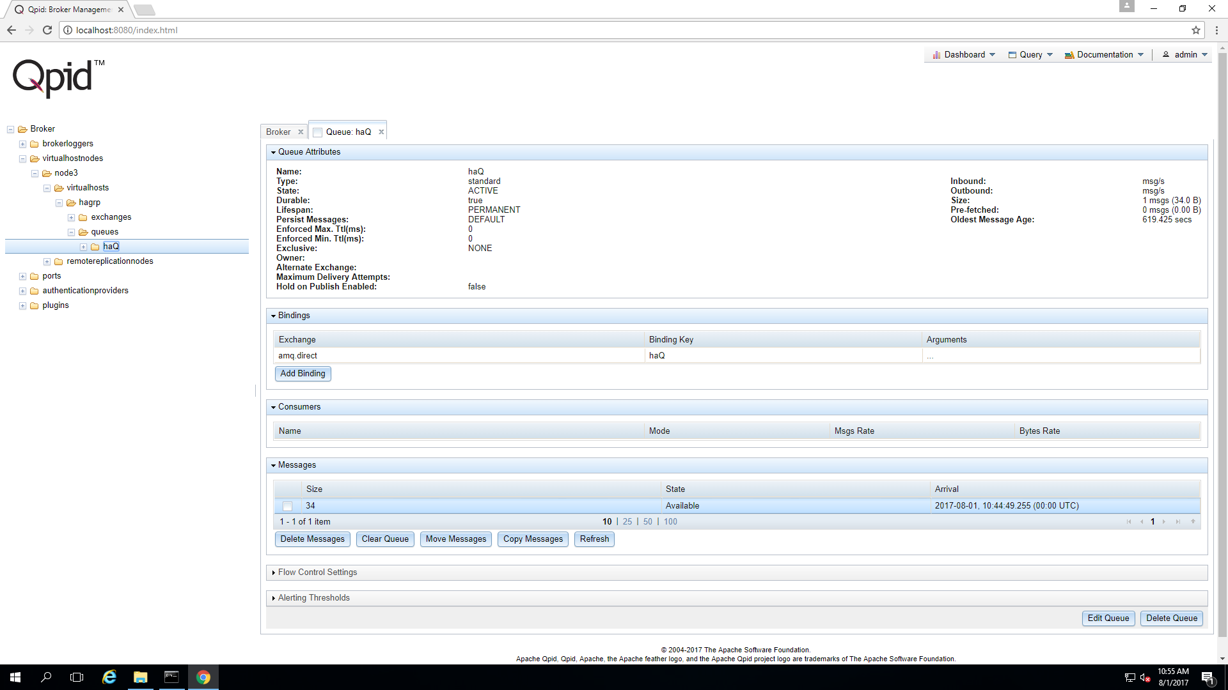

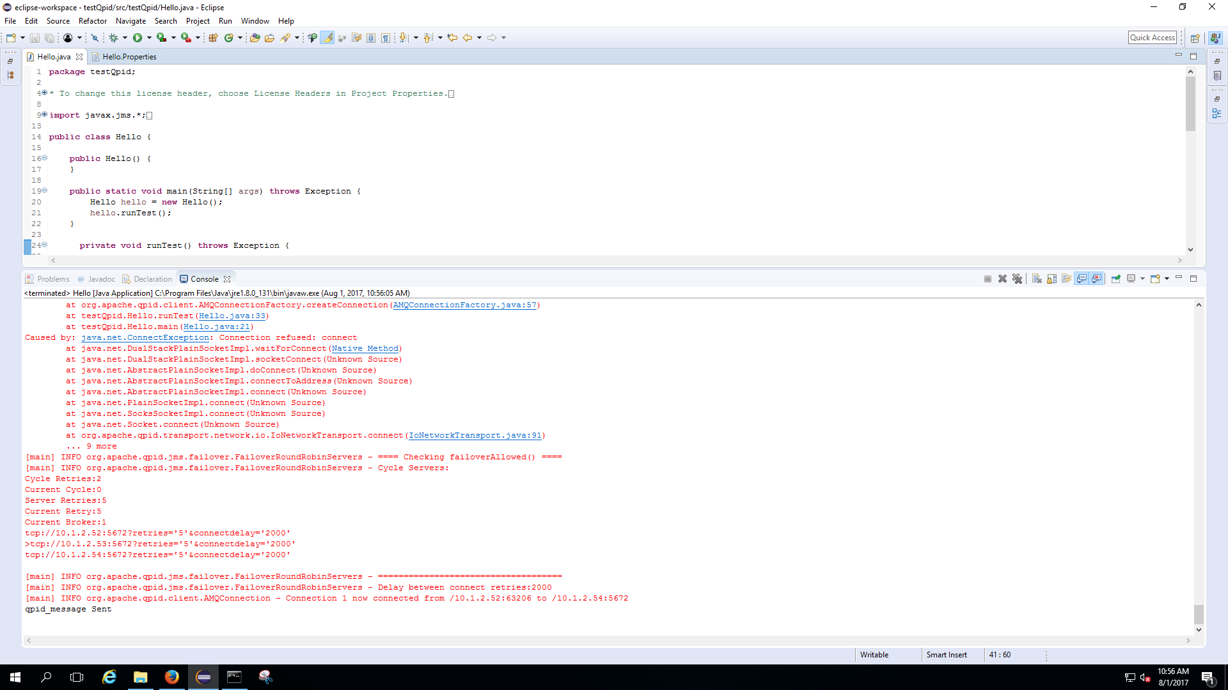
- If you send new message, automatically it will connect to the new MASTER I,e node3 and sends the message
- Find the new message in node3
